

IF Webtoon

Group 3

Names : Ferdiansyah

Class : 4SC5

CEP CCIT

FAKULTAS TEKNIK UNIVERSITAS INDONESIA

2020

**Developed by**

**Ferdiansyah**



**PROJECT ON**

*IF Webtoon App*

**IF Webtoon App**

Batch Code : 4SC5

Start Date : 03 April   
End Date : 17 April

Name of Faculty : Fachran Nazarullah, S.KOM

Names of Developer : Ferdiansyah

Date of Submission: 20 April

**CERTIFICATE**

This is to certify that this report titled “IF Webtoon” embodies the original work done by Ferdiansyah. Project in partial fulfillment of their course requirement at NIIT.

Coordinator:

Fachran Nazarullah, S.KOM



**ACKNOWLEDGEMENT**

First of all, we want to send our gratitude to Allah SWT because of his grace, we finished writing the paper entitled "IF Webtoon" within the deadline. The purpose of writing this paper is to fulfill the assignment given by Mr. Fachran Nazarullah, S.Kom. As a lecturer in CEP-CCIT FTUI.

This project is composed, organized, and written by us, and it has been done by following the research regarding the project from trusted sources. We wanted to say thanks to our faculty that provides information and data relevant to our project, so that we can complete the project in an orderly fashion. Lastly, we would like to apologize for any mistakes that we made, either that is regarding, grammar, misinformation, or simply the project is not written orderly or efficiently.

**SYSTEM ANALYSIS**

**System Summary**:

The IF Webtoon project is a comic website that aims to give the users a wide variety of webcomics from various verified artists and provide a reliable source of income to artists that uses our platform. IF webtoon compromises of HTML5, JavaScript, and JSON, to provide a responsive website and gives the user a “smoother” feeling when exploring the website.

**DESIGN INTERFACE**

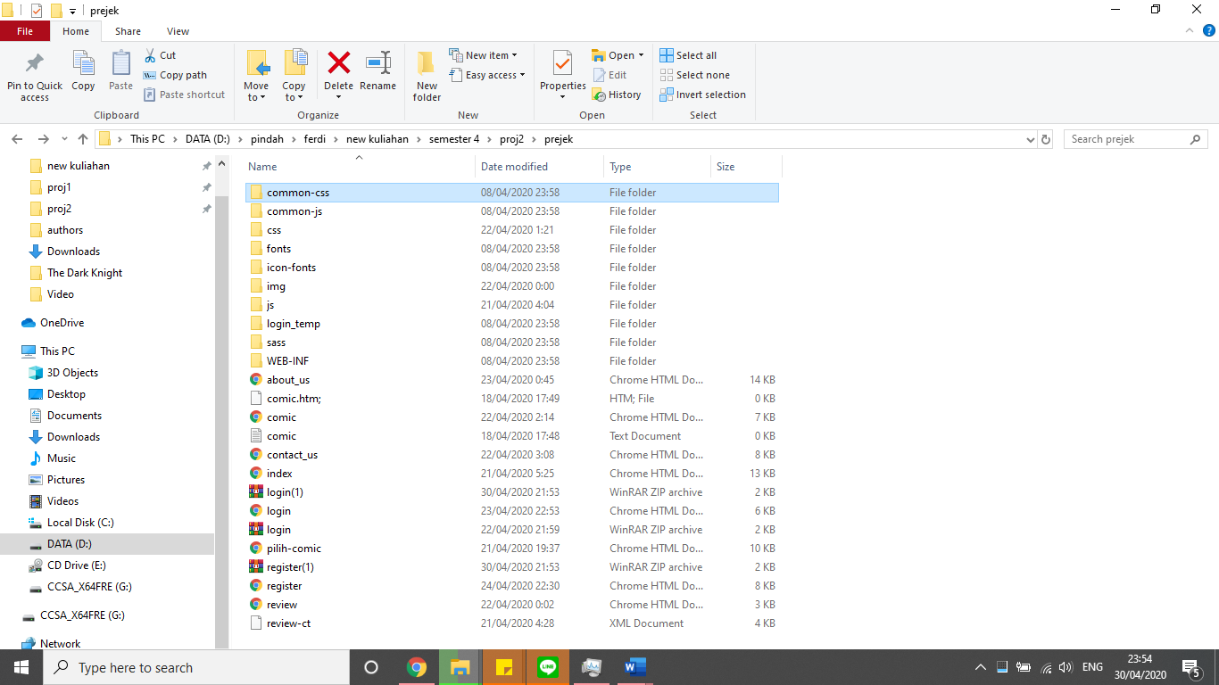

\

sssssssssss

**USER INTERFACE**

1. **Home menu / index**

**Computer web interface**

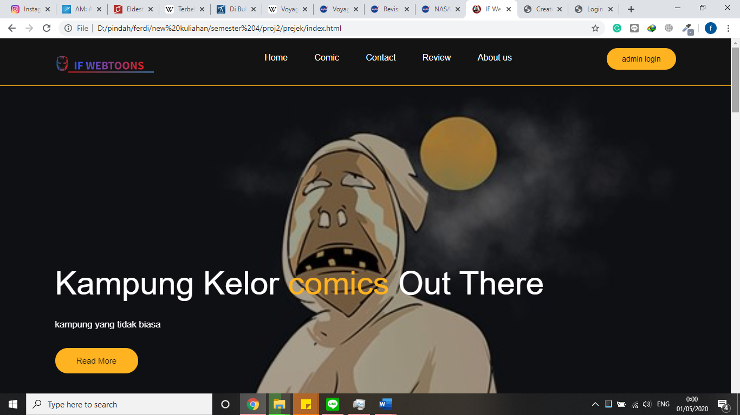

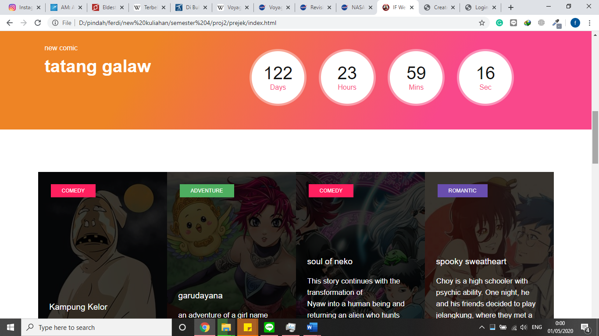

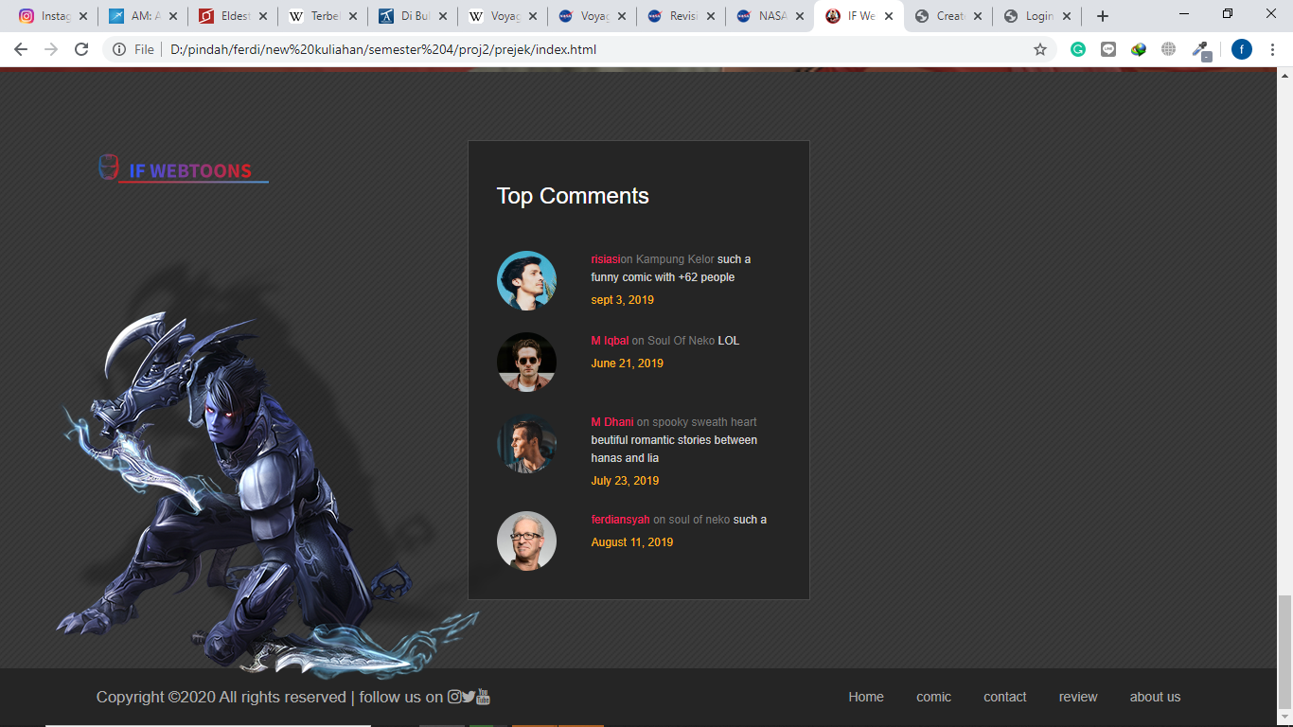

**Mobile interface**

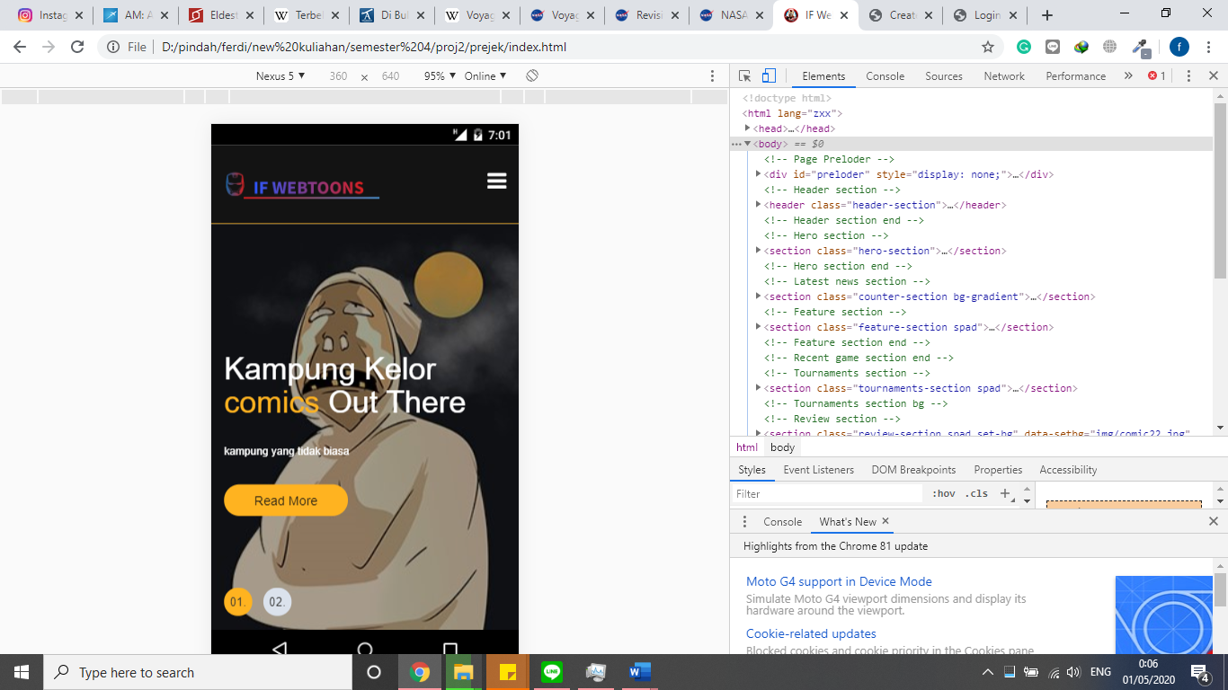

**USER INTERFACE**

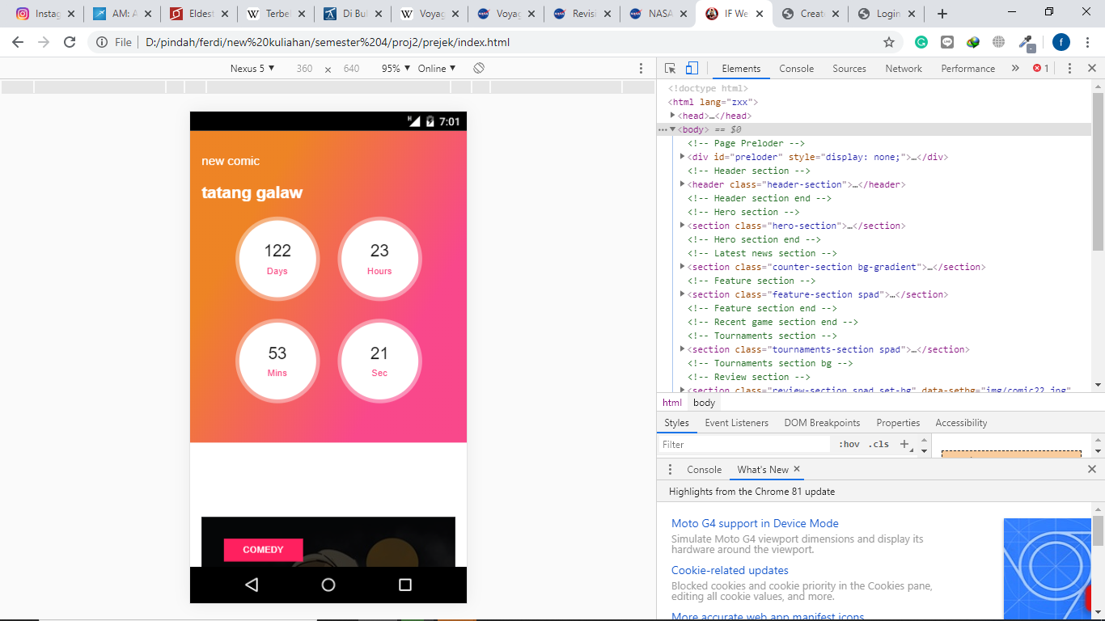

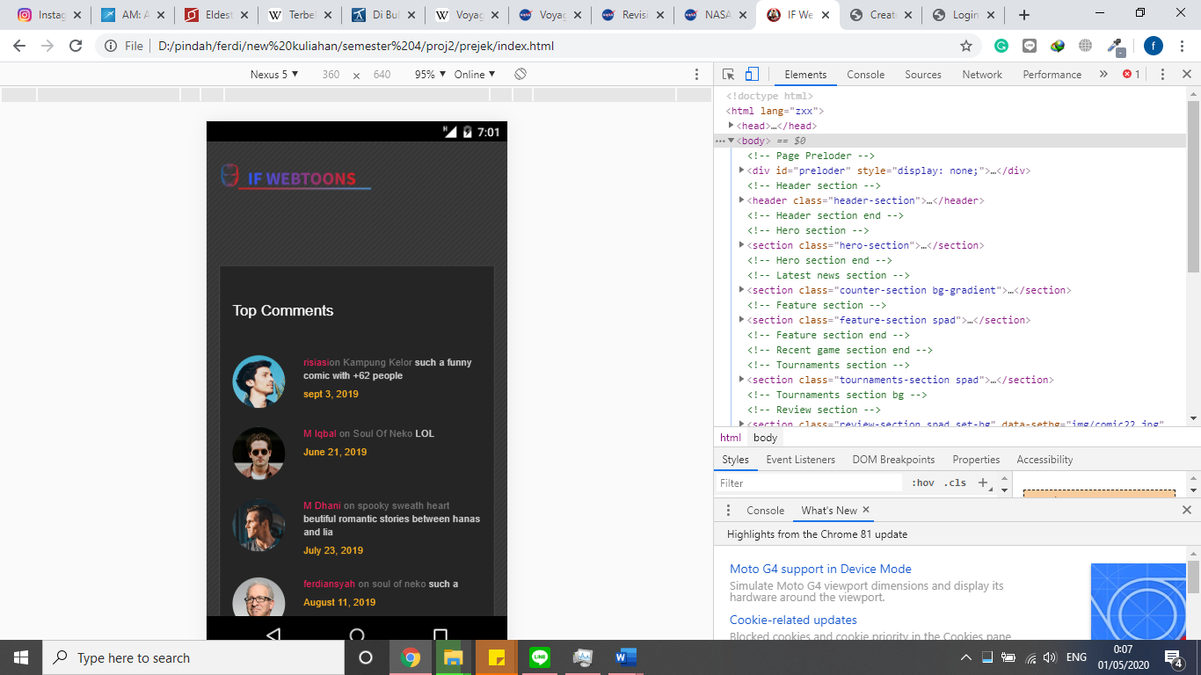

**USER INTERFACE**

**USER INTERFACE**

**2. choice a comic**

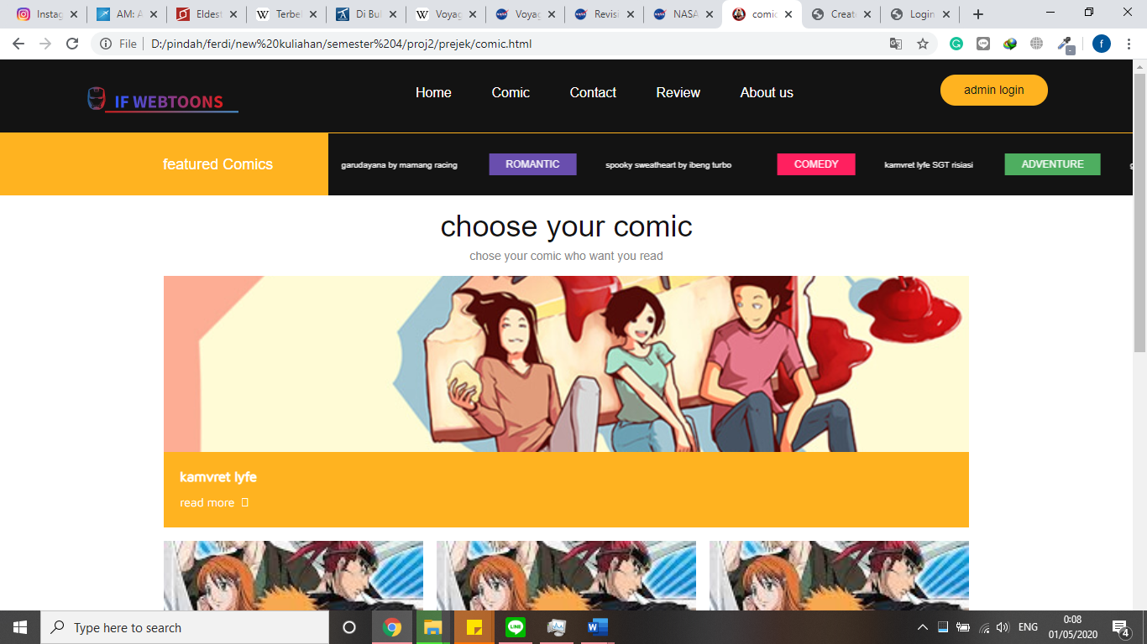

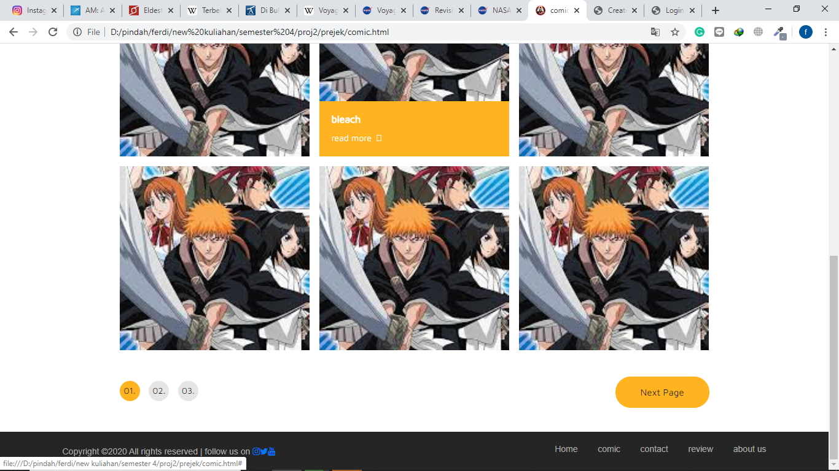

**USER INTERFACE**

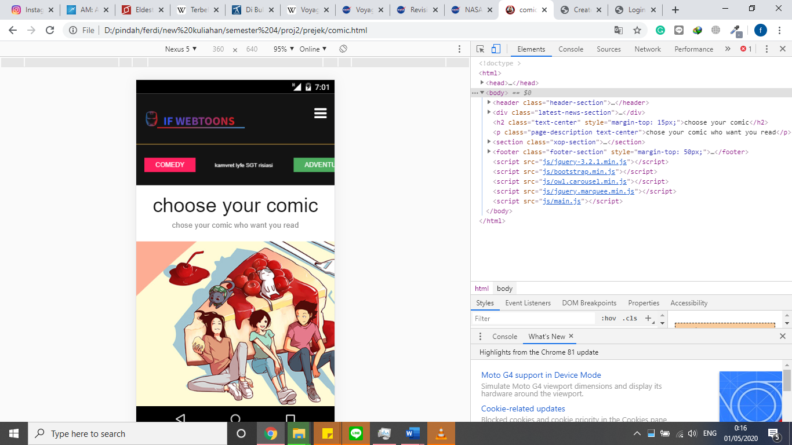

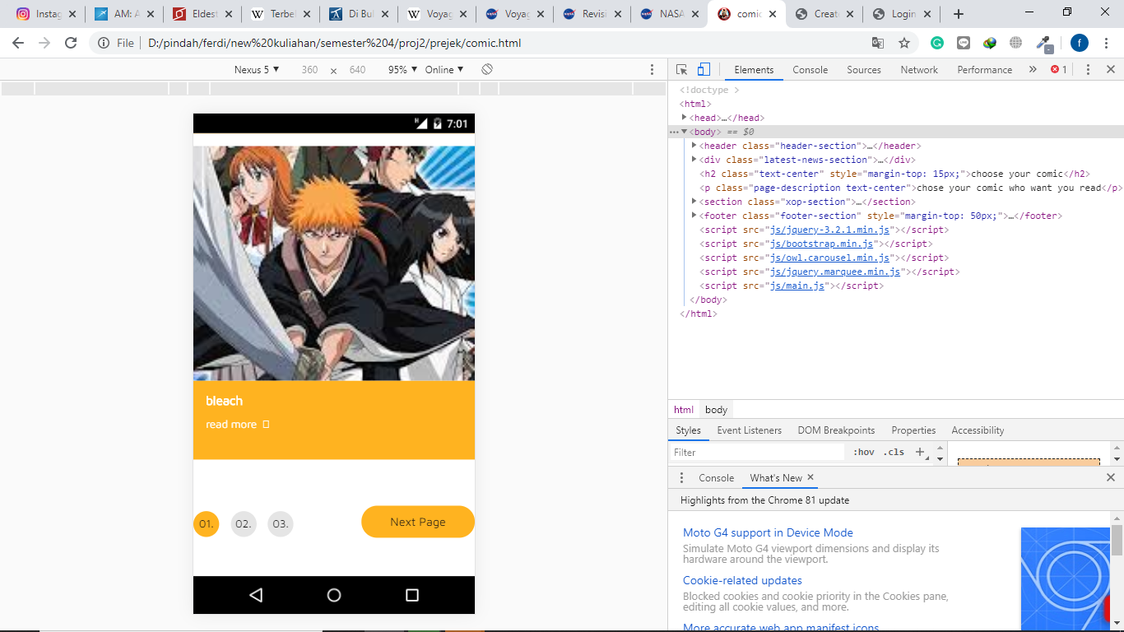

**USER INTERFACE**

**3. read comic menu**

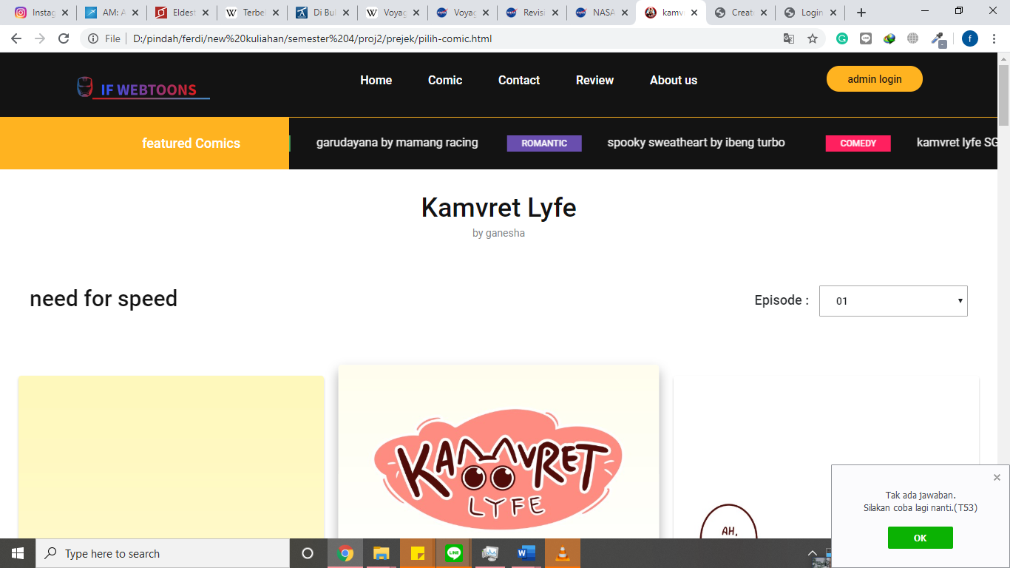

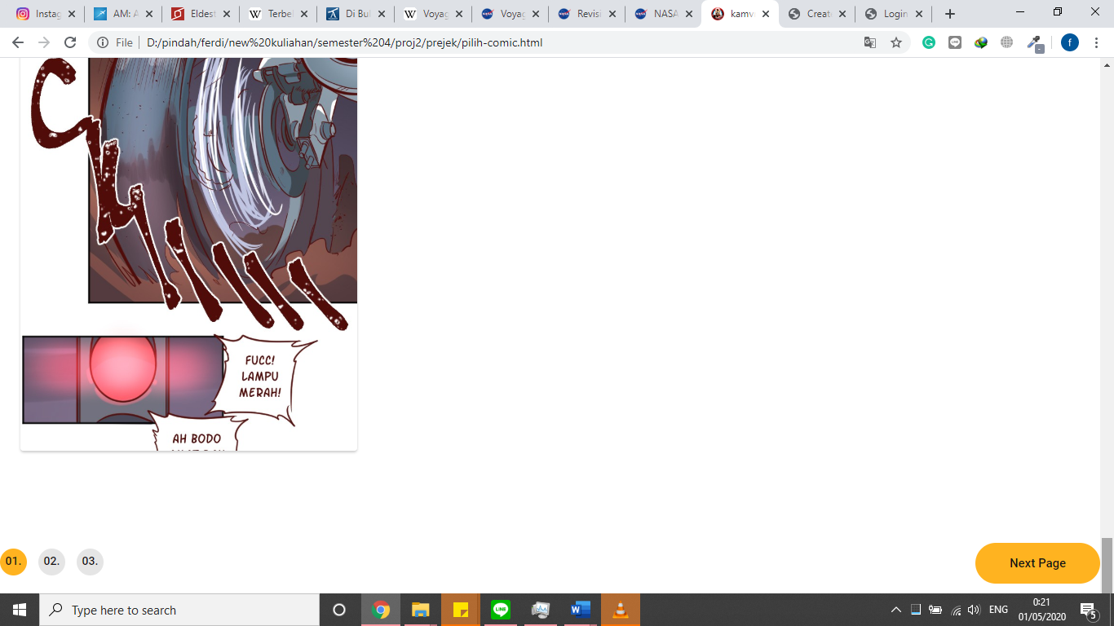

**USER INTERFACE**

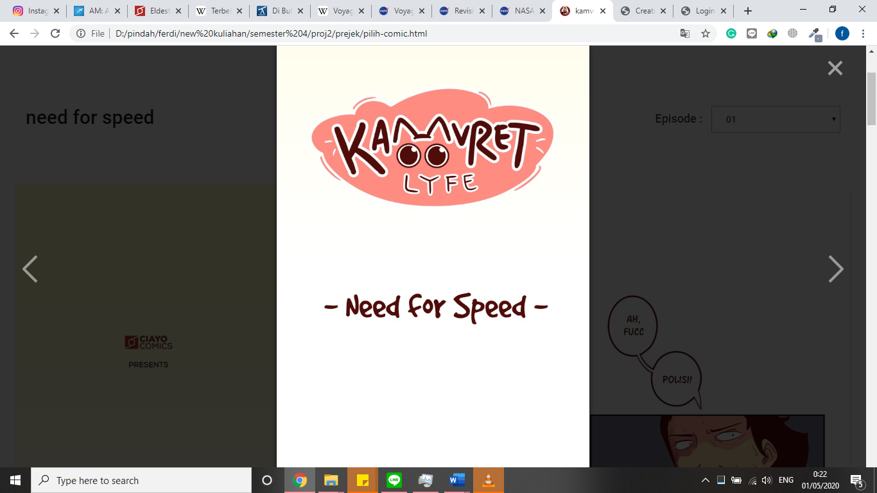

**Mobile interface**

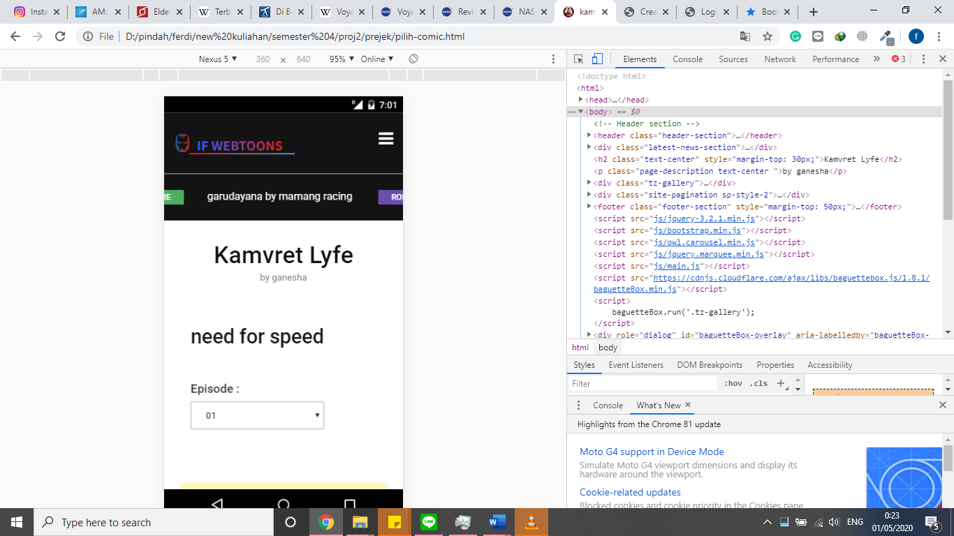



**USER INTERFACE**

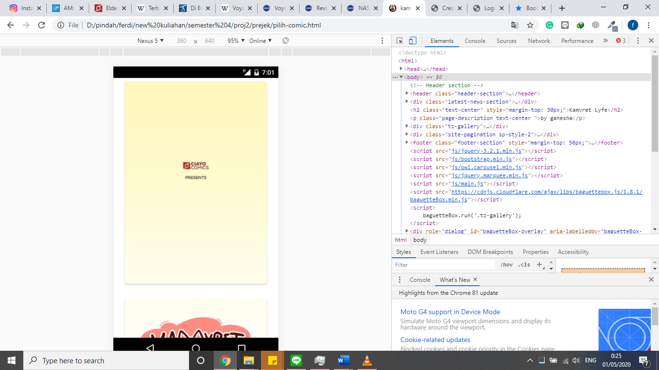

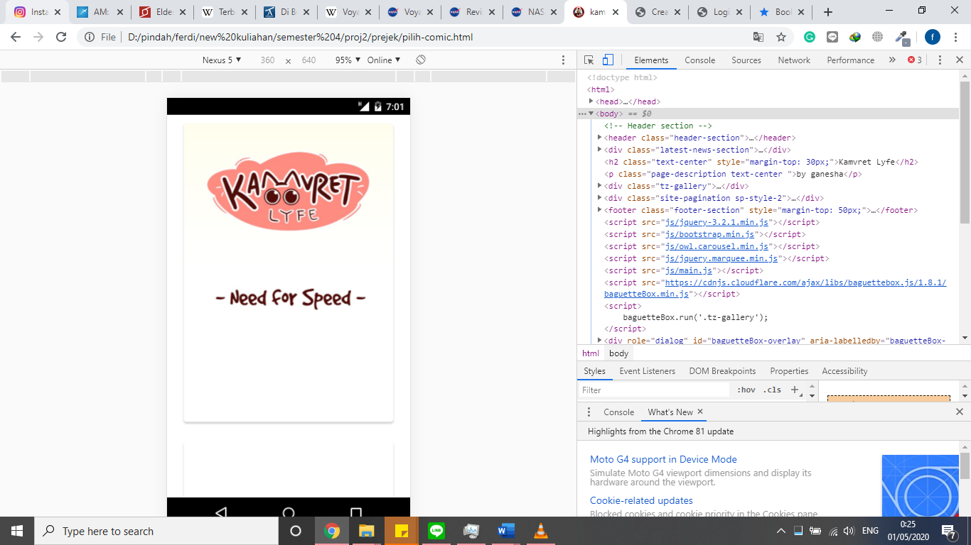

**USER INTERFACE**

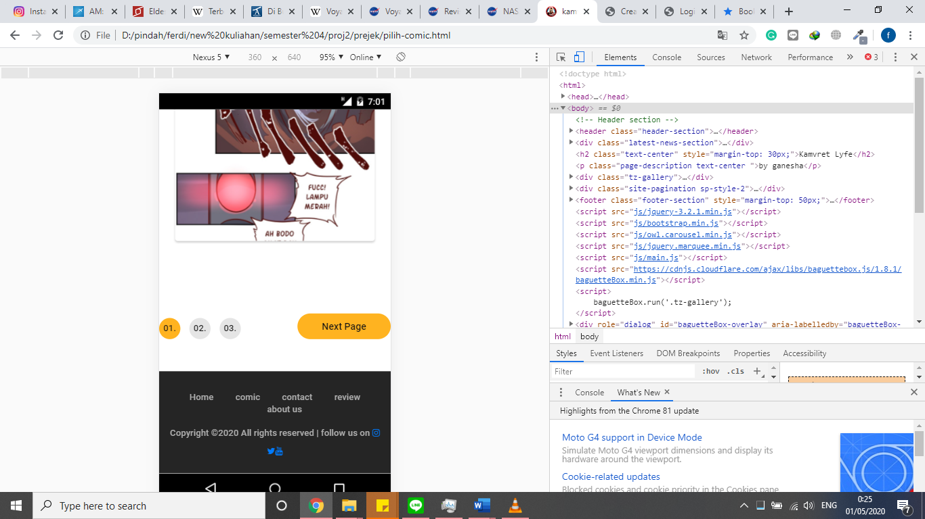

**4. contact us menu**

**Computer design interface**

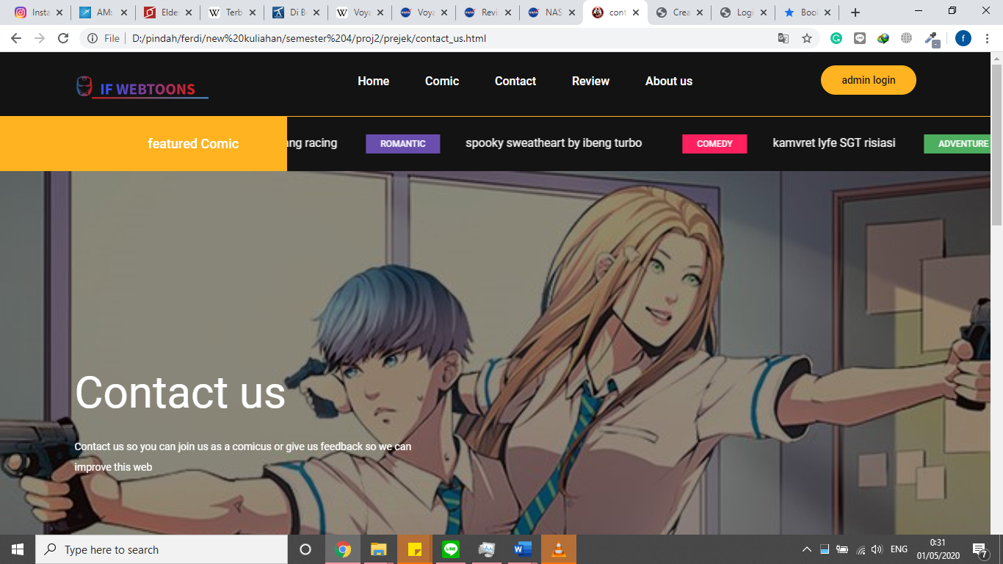

**USER INTERFACE**

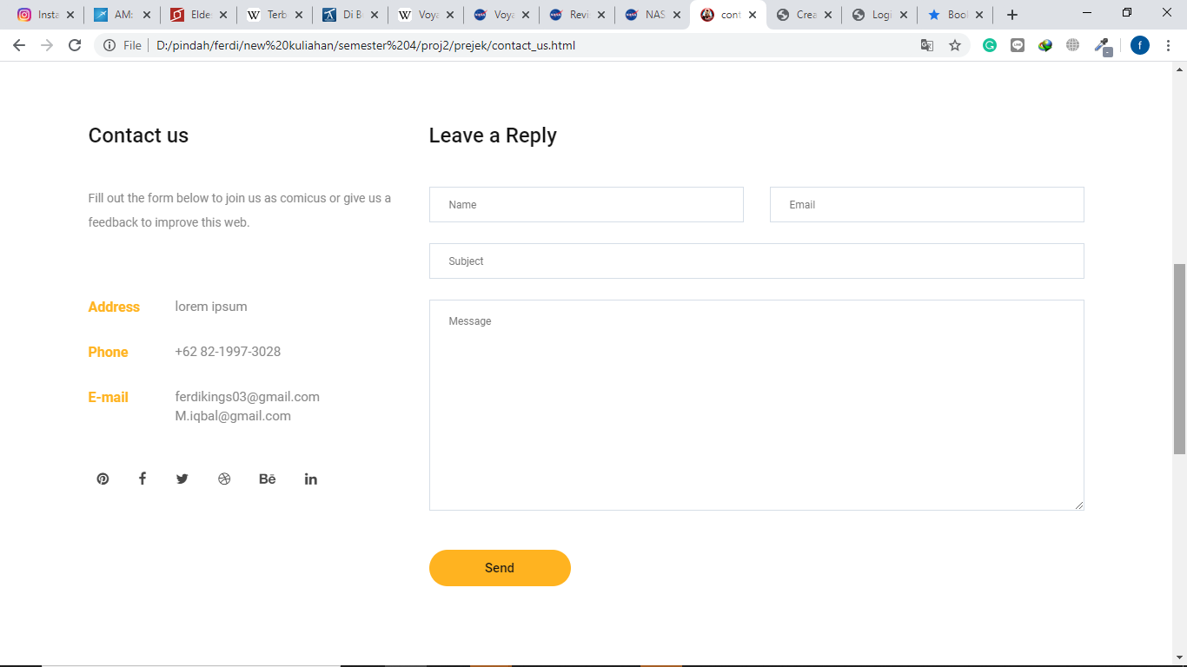

**Mobile design interface**

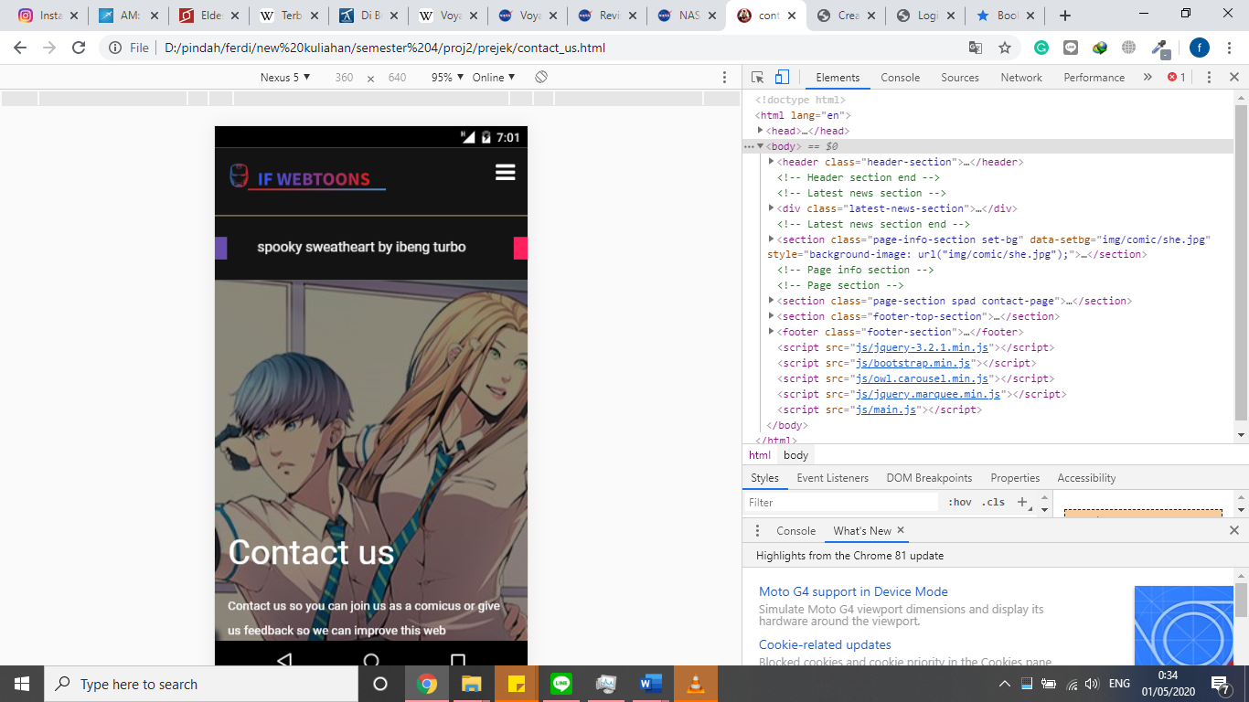

**USER INTERFACE**

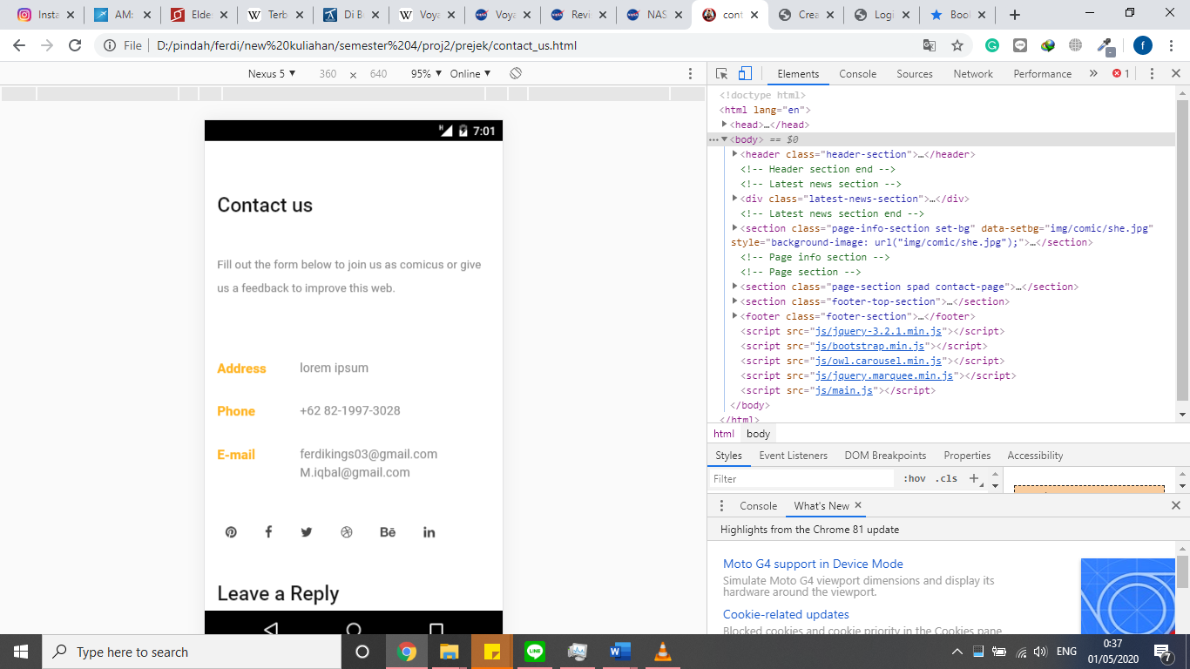

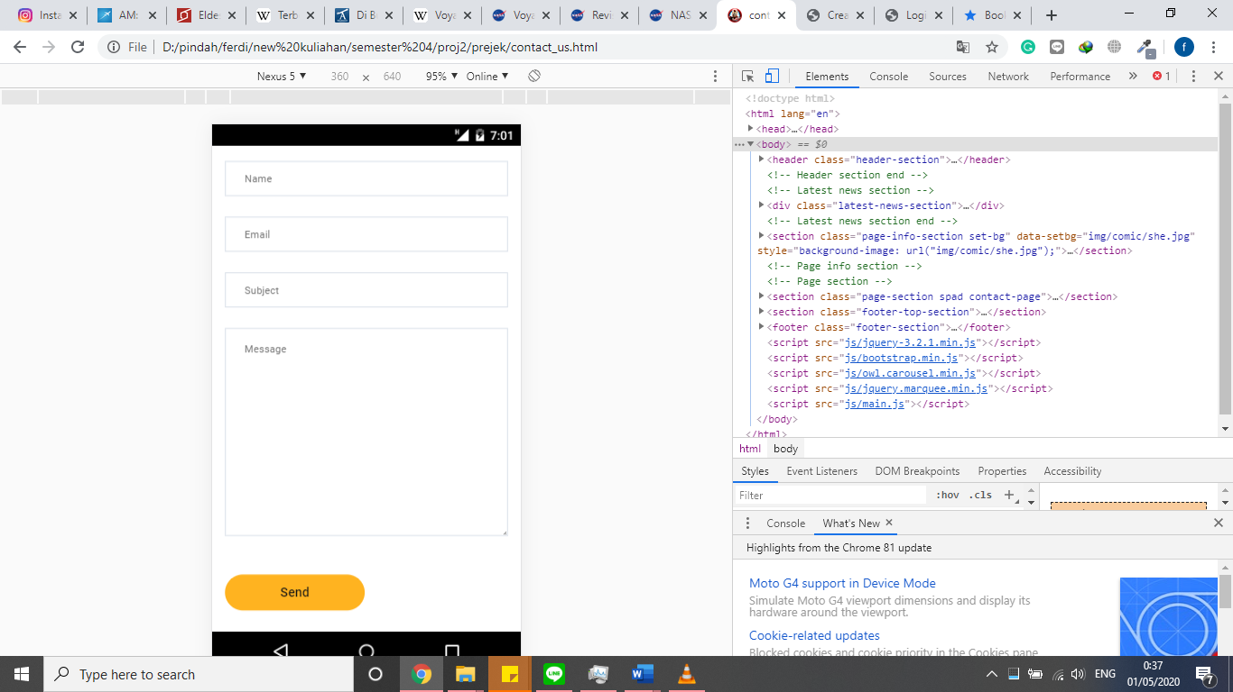

**USER INTERFACE**

**5. review menu**

**Computer design interface**

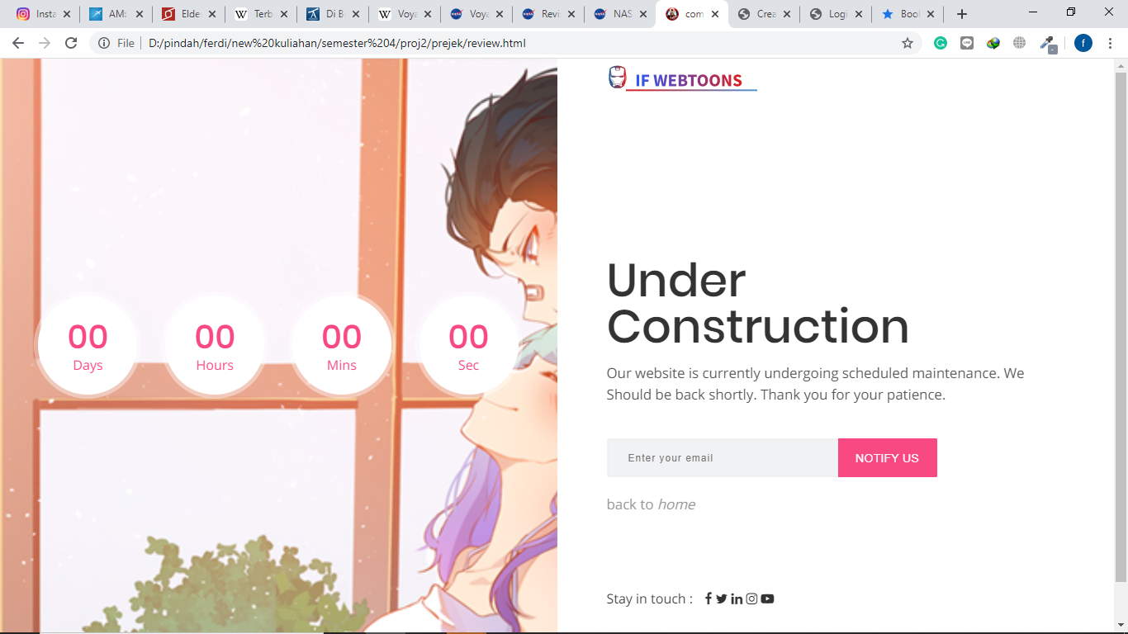

**mobile design interface**

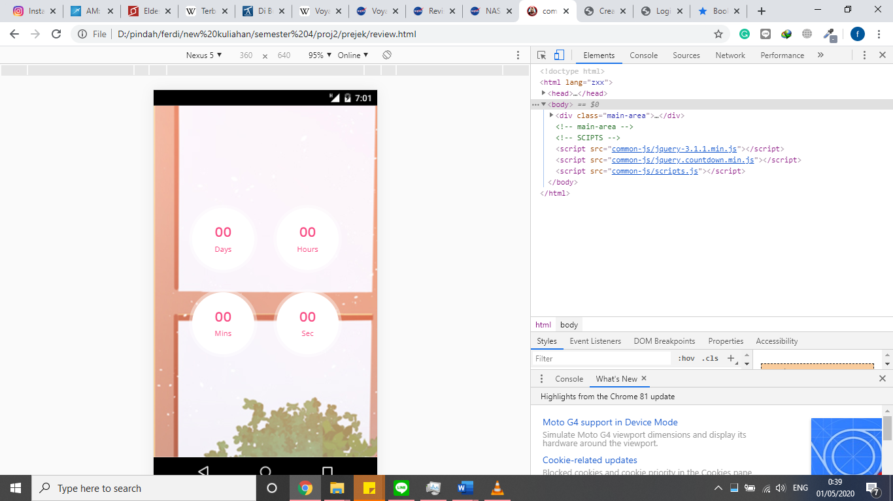

**USER INTERFACE**

**6. login**

**Computer design interface and jquery**

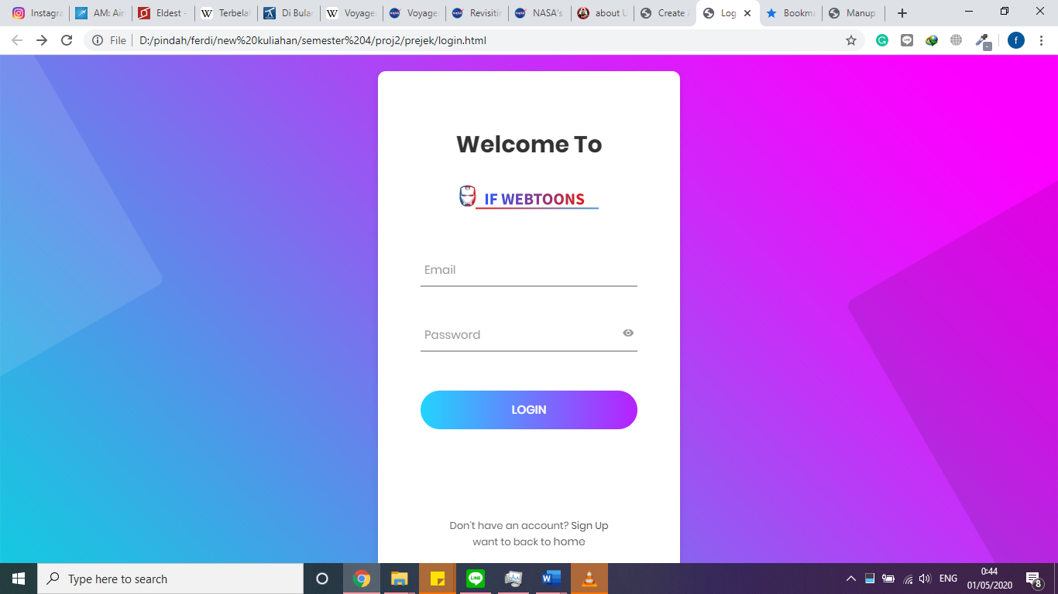

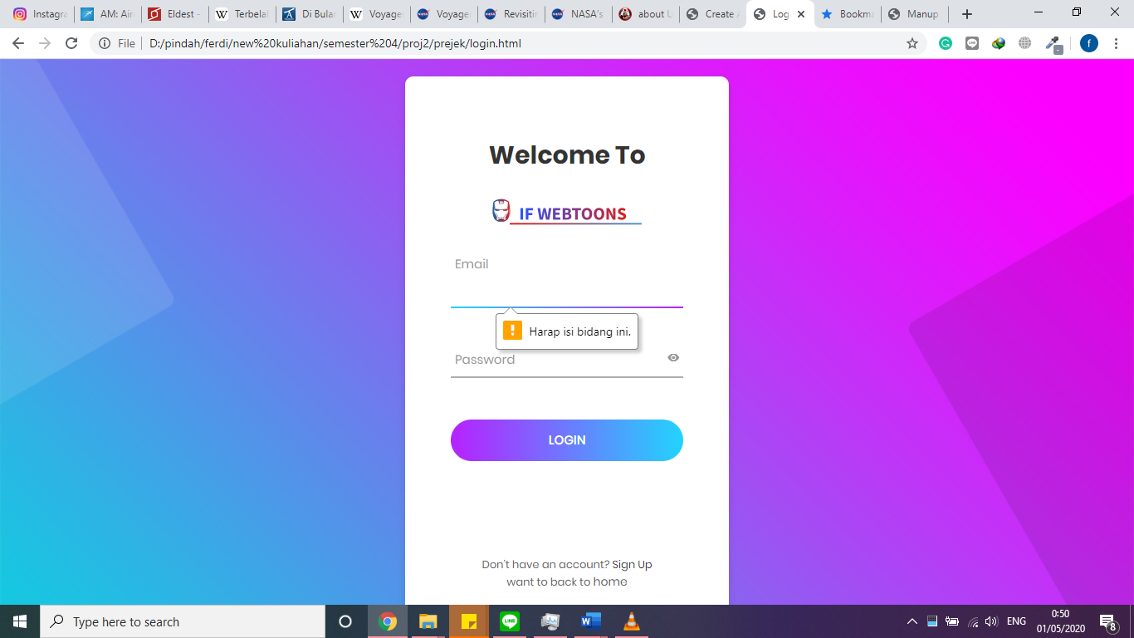

**Login in mobile interface**

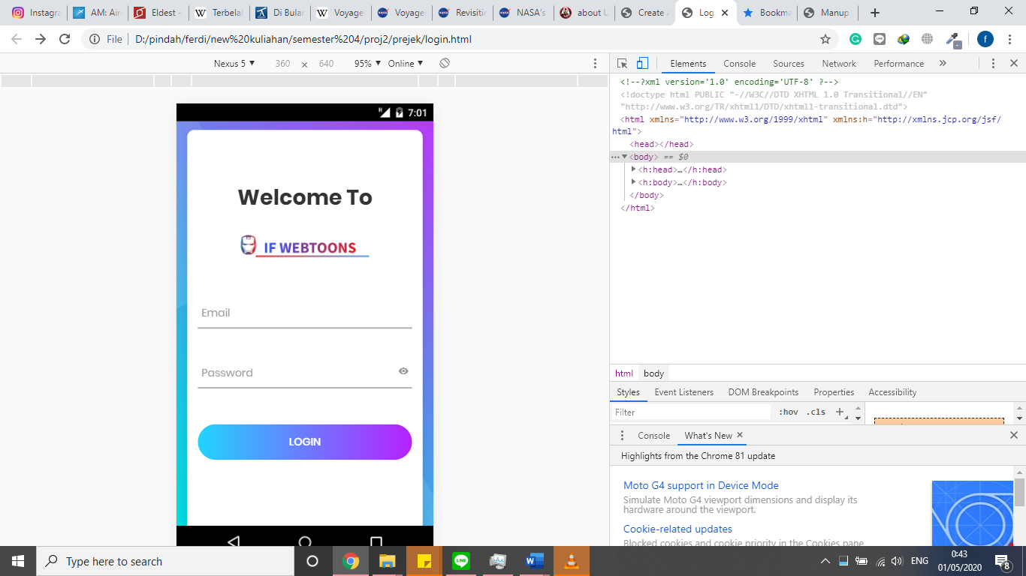

**6. login**

**Computer design interface and jquery**

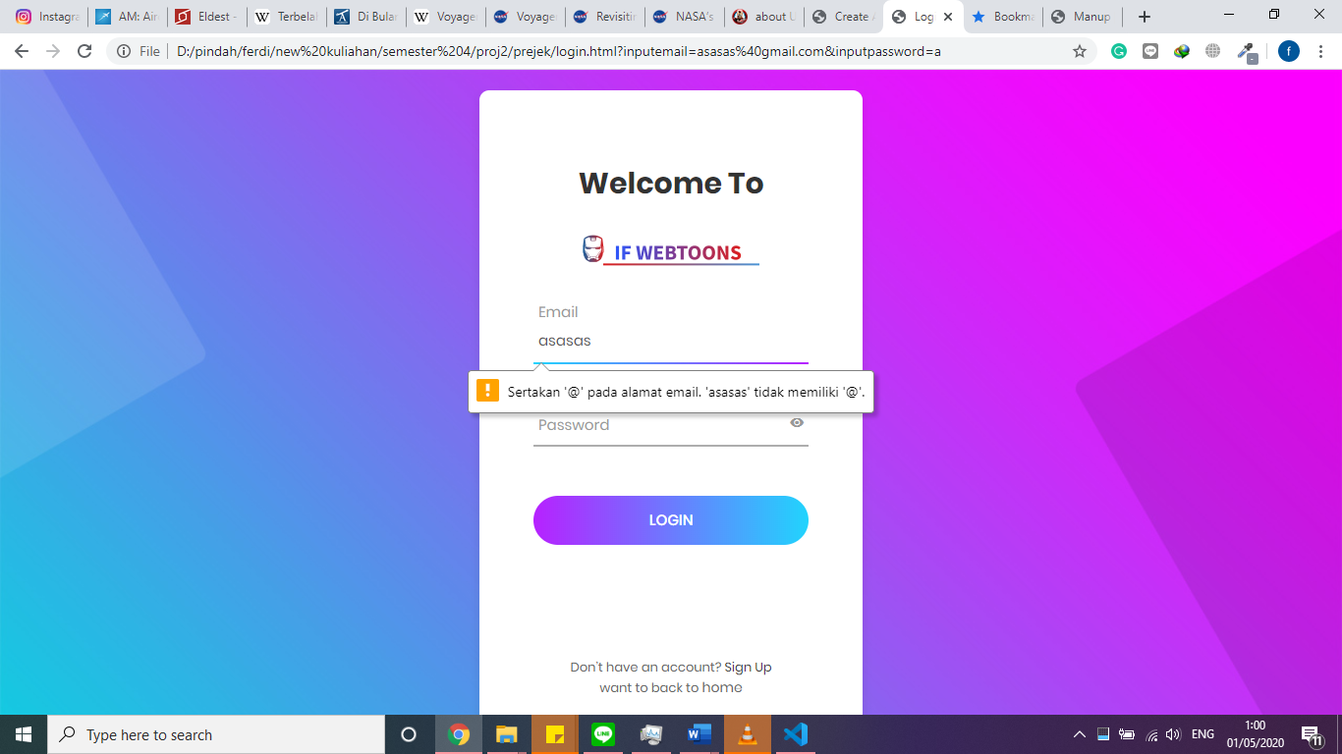

**Login in mobile interface**



**USER INTERFACE**

**6. login**

**Computer design interface**



**Login in mobile interface**



**USER INTERFACE**

**6. register**

**Computer design interface**

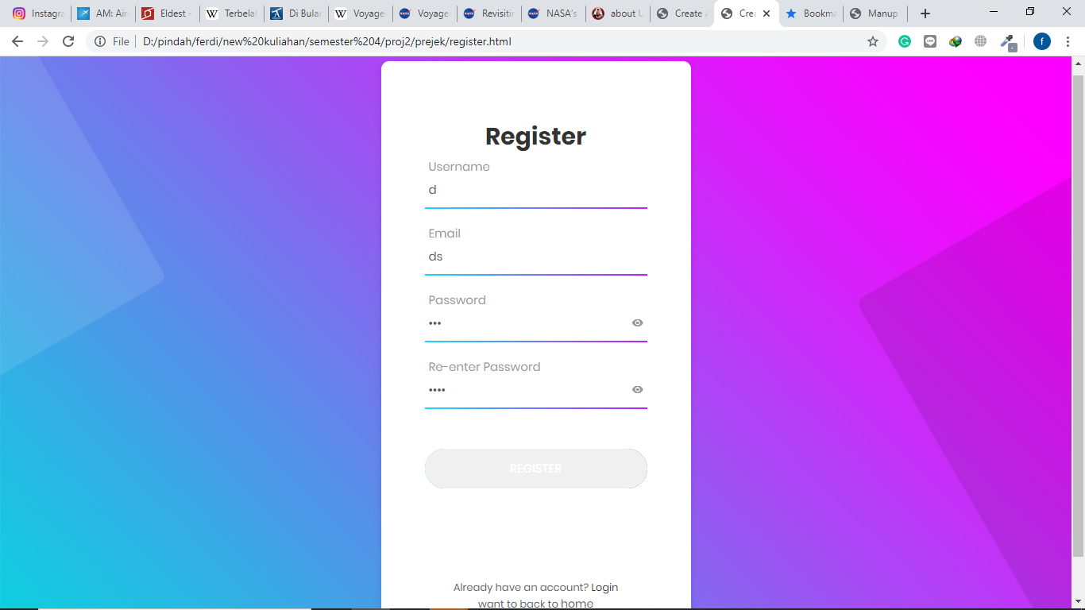

**Login in mobile interface**

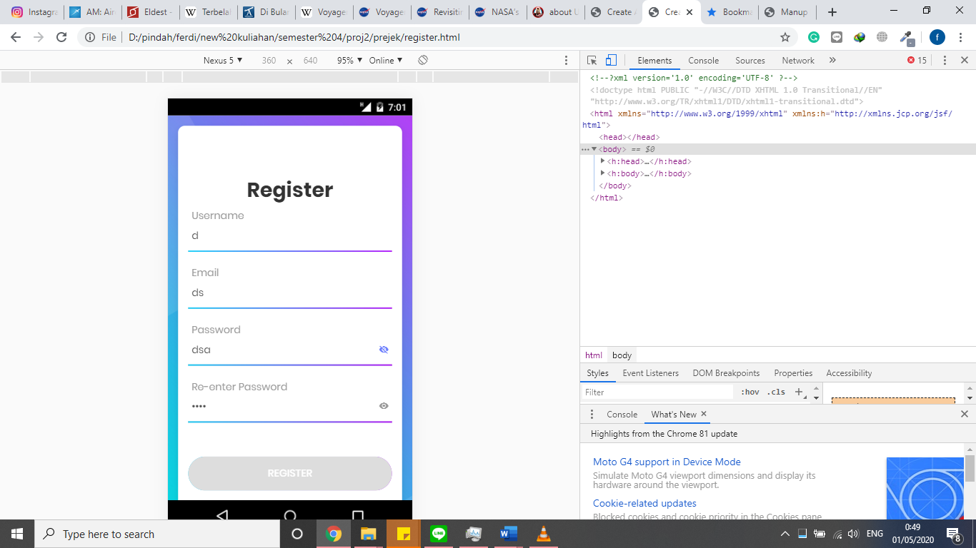

**USER INTERFACE**

**Hardware** :

PC compatible with an Intel Core – i5 processor, 8 GB RAM and 128 GB of SSD

**Operating System** :

Microsoft Windows 10

**Software** :

Microsoft studio code

Sublime text 3

|  |  |  |
| --- | --- | --- |
| **PROJECT FILE DETAILS** | | |
| **S.No** | **File Name** | **Remarks** |
| 1. | .html | Html project is for interface |

**CONFIGURATION**

**PROJECT FILE DETAILS**

|  |  |  |
| --- | --- | --- |
| **S.No** | **File Name** | **Remarks** |
| 1 | Index.html | The home web page |
| 2 | Login.html | The page for login |
| 3 | Register.html | The register screen |
| 4 | Comic.html | The comic page that contains preview images of the comic |
| 5 | Pilih-comic.html | The page that contains reading view of comic images |
| 6 | About_us.html | The that contains information about IF Webtoon |
| 7 | Contact_us.html | The page that contains a feedback form |
| 8 | Review.html | The page that contains a countdown and serve as a |

\

sssssssssss